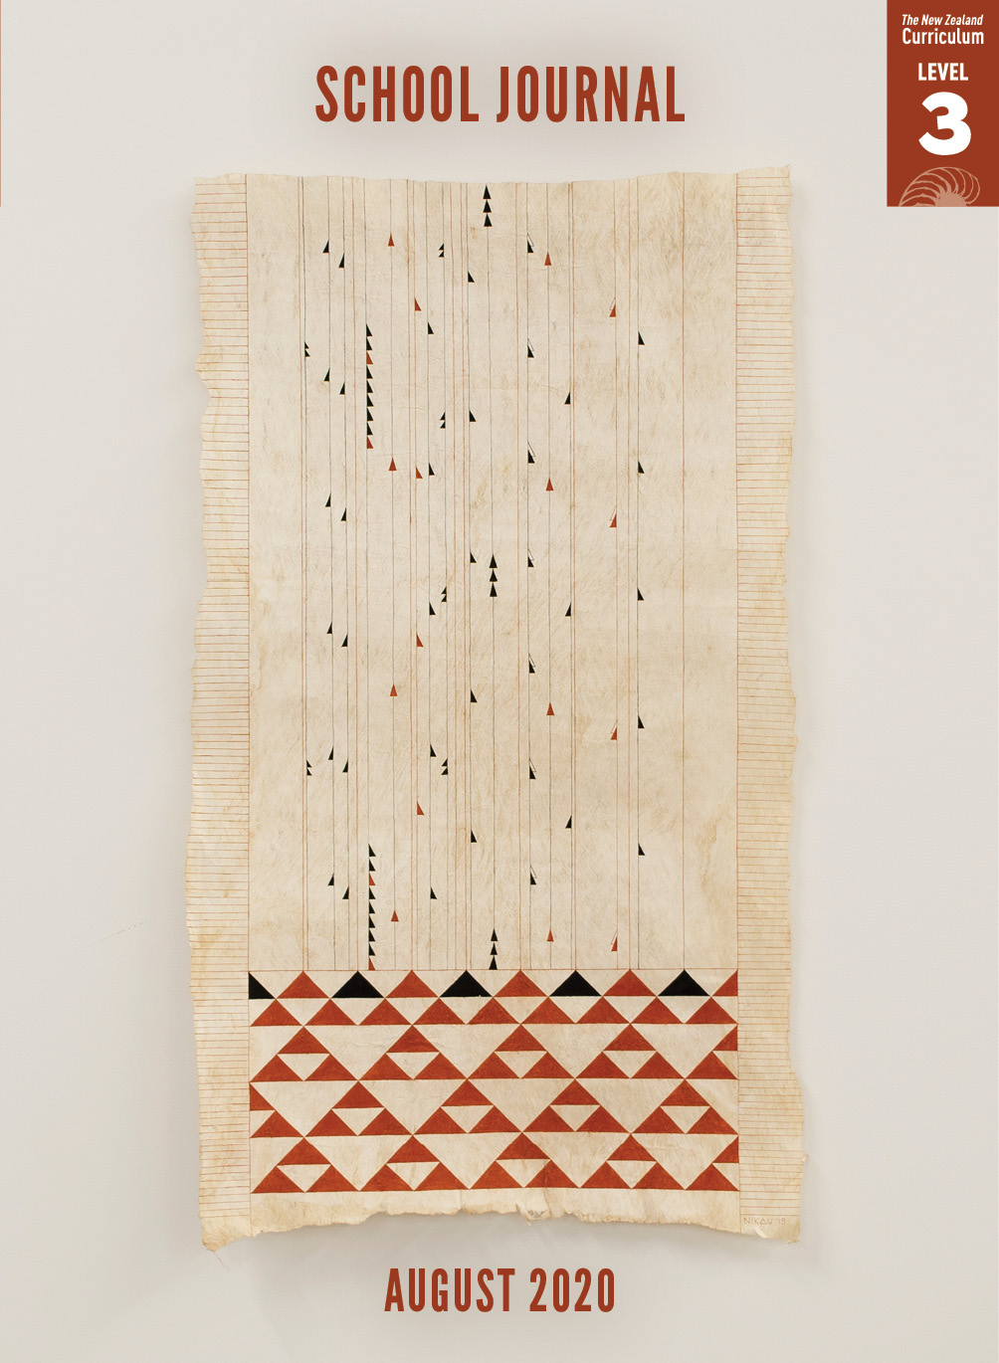

School Journal

Level 3, August 2020

**Year 5**

**Tuālima**

**by Tusiata Avia**

The[Learning Progression Framework](https://curriculumprogresstools.education.govt.nz/lpf-tool/)s describe significant signposts in reading and writing as students develop and apply their literacy knowledge and skills with increasing expertise from school entry to the end of year 10.

## Overview

Tusiata Avia writes from the child’s perspective as the narrator’s mother receives a tuālima (a tattoo on the back of the hand).   
Arranged chronologically, the author details particulars of the ceremony, sometimes using gagana Sāmoa terms, and sharing   
the attention equally between what’s happening and the emotions felt.

A PDF of the text is available at [www.schooljournal.tki.org.nz](http://www.schooljournal.tki.org.nz).

## Themes

|  |  |  |  |
| --- | --- | --- | --- |
| * Culture and identity | * Relationships | * Endurance |  |

## Related texts

**“Kilikiti”** SJ L3 Nov 2018 | **“For the Ancestors: One Woman’s Malu”** SJ L3 Nov 2019 | **“Brave Flower”** SJ L4 Nov 2018 |   
**“River Swimming”** SJ L3 June 2018 | **“Leaves”** SJ L4 May 2020 | **“Thumbprints”** SJ L3 May 2017

## Strengthening reading behaviours (what to notice)

|  |  |
| --- | --- |
| Text structure and features | Requiring students to: |
| * Implied information *Mum is smiling at me, nodding I know she is telling me not to worry, Pa is here with us, too* * Repetition of words/phrases *tap, tap, tap and wipe* * Samoan words not explained *See below* | * connect the statement at the beginning of the poem that it is one year since Pa died with the ghost-like appearance of the father in the eighth stanza to make the inference that the ceremony is marking this anniversary * use the repetition to understand and visualise the process (and the length of time involved) * make inferences, using the setting and context to interpret meaning |

|  |  |
| --- | --- |
| Vocabulary | |
| Words and phrases in gagana Sāmoa | Tufuga tā tatau (master of traditional tattooing), au (tattooing needle or comb),  ‘o le māfua‘aga (title of a well-known song; māfua‘aga = origin),  Pālagi (non-Samoan person), tuālima (hand tattoo), malu (female tattoo),  siva (a Samoan dance) |

|  |
| --- |
| Helpful prior knowledge |
| * Knowledge of tatau/tattoo * Knowledge of Pacific cultures and customs |

## Possible reading and writing purposes

* Discover the experience of a woman receiving a tattoo, as observed through the eyes of her daughter
* Identify and analyse the structure of the poem
* Identify and evaluate the purpose and effectiveness of the writer’s language devices

See *Effective Literacy Practice in Years 5–8* for information about teaching comprehension strategies ([Teaching comprehension](http://literacyonline.tki.org.nz/Literacy-Online/Planning-for-my-students-needs/Effective-Literacy-Practice-Years-5-8/Teaching-comprehension)) and for suggestions on using this text with your students ([Approaches to teaching reading](http://literacyonline.tki.org.nz/Literacy-Online/Planning-for-my-students-needs/Effective-Literacy-Practice-Years-5-8/Approaches-to-teaching-reading)).

## Possible curriculum contexts

This text has links to level 3 of *The New Zealand Curriculum* in: [**ENGLISH**](http://nzcurriculum.tki.org.nz/The-New-Zealand-Curriculum/English) [**SOCIAL SCIENCES**](http://nzcurriculum.tki.org.nz/The-New-Zealand-Curriculum/Social-sciences)

## Understanding progress

The following aspects of progress are taken from the [Learning Progression Framework](https://curriculumprogresstools.education.govt.nz/lpf-tool/)s and relate to the specific learning tasks below. See the LPFs for more about how students develop expertise and make progress in these aspects:

* Reading for literary experience
* Making sense of text: reading critically
* Making sense of text: using knowledge of text structure and features
* Using writing to think and organise for learning.

## Strengthening understanding through reading and writing

The *School Journal* provides rich texts that can be returned to many times. The following suggestions are based on the premise that rereading the text is a fundamental part of developing students’ understanding and reading skills. **Select from and adapt** them according to your students’ strengths, needs, and experiences.   
Note: Most of these activities lend themselves to students working in pairs or small groups.

* Have the students record their response to the poem, including what they liked, images and themes they noticed, and what they think the poet is saying. You could use the poem response template included in the *School Journal*, Level 4, May 2020 TSM for “Leaves”.
* Review strategies the students can use to work out unfamiliar vocabulary such as clarifying the context, rereading and looking for clues, predicting and reading on to see if their predictions makes sense, and making links to their prior knowledge. For example, they could look for connections with similar words in other languages, such as tattoo.
* Encourage the students to make connections to the poem by linking to ceremonies or anniversaries that they celebrate. *Do these have any similarities or differences with what happens in the poem? Is food, song, and/or dance involved?*
* Explore the photograph. The students could play a game of “I spy” with a partner to draw attention to the various details. Encourage the students to question what the patterns and symbols might mean. Have them do further research to find out or confirm their answers.
* Have groups of students create [freeze frames](https://esolonline.tki.org.nz/ESOL-Online/Planning-for-my-students-needs/Resources-for-planning/ESOL-teaching-strategies/Thinking-and-metacognition/Freeze-frame) for each verse in the poem.
* Have the students create a character map for Mum. Encourage them to look for evidence in the poem of qualities that describe her.  You could create a template for the students to fill in using [Google Slides](https://www.google.com/slides/about/), with a character map image set as the background.
* Discuss the layout of the poem: *What does the poem look like on the page? Are there any “rules” it is following?* Remind the students of terms they can use to talk about the poem’s form, for example, stanzas, verse, refrain, repetition, line length, rhythm, rhyme, free verse, and open form. (The lines are short and most don’t run on. No rhyme. Punctuation includes full stops, dashes, colons, and italics.)
* Explore the poet’s use of repetition. Have the students remove the repetition from the poem and see what effect it has. Focus on the imagery the repetition creates and the effect it has on the poem’s structure.
* Have the students complete the **Inferences T-chart** to unpack the story in the poem. In the left-hand column they write quotes from the poem that provide evidence for their inferences, and in the right-hand column they explain what they have inferred about the characters and events.
* Ask the students to use the poem as a model to write about their own experience with a ceremony, for example, a family wedding or a school prize-giving. Set writing challenges such as including a repetitive sound pattern to separate stanzas, using a list, adding dialogue, and so on.
* Have the students retell the poem as a news item, using the information from the poem. *What happened? When did it happen? Why did it happen? Where did it take place? Who was involved? How did it happen?*

|  |
| --- |
| “Tuālima” Inferences T-chart |

In the left-hand column, note what happens and/or what is said in the poem that reveals something about the narrator or about what is happening. In the right-hand column, say what it reveals.

|  |  |
| --- | --- |
| Evidence – quotes from the text | Inferences about characters and events |
| *My mum is strong* I say.  My heart swells with pride. | The narrator is proud of her mother. |